Assignment 07: Functions

# Introduction

This week’s lesson was primarily focused on functions. A function is a named piece of SQL code used to perform a task. There are many built in functions, and users can also create their own functions (User Defined Functions, UDF).

# Explain when you would use a SQL UDF

SQL UDFs are used to store a piece of code used to perform an action and have it easily recalled later when necessary. Creating a function and calling it later is a way to keep code organized as well. When the operation is required multiple times, a user define function is an efficient method to accomplish this. Figure 1 below shows an example of this assignments UDF.

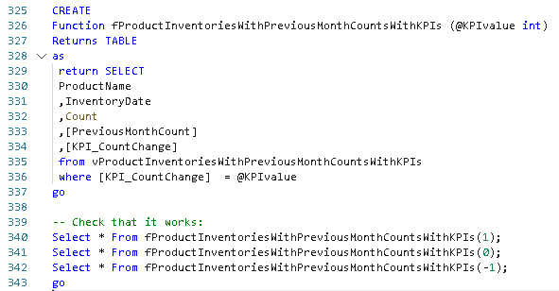

***Figure 1: Example of UDF, user selects which KPI value to include in the returned table***

# Explain the differences between a Scalar, Inline, and Multi-Statement Functions

Scalar functions return only a single value. The data type of the single value in the RETURNS clause of the function must be identified. In Figure 1, this is done in line 326 (@KPIvalue int). Inline functions only need RETURNS TABLE specified and the table’s definition will be based on the functions SELECT statement. A BEGIN/END syntax is not needed for an inline function. Multi-Statement functions have a RETURNS syntax that specifies the structure of the return table. A BEGIN/END syntax is required for a multi-statement function.